1. Search for the **anaconda prompt** in Windows and open it. (No matter if Anaconda 2 or Anaconda 3)

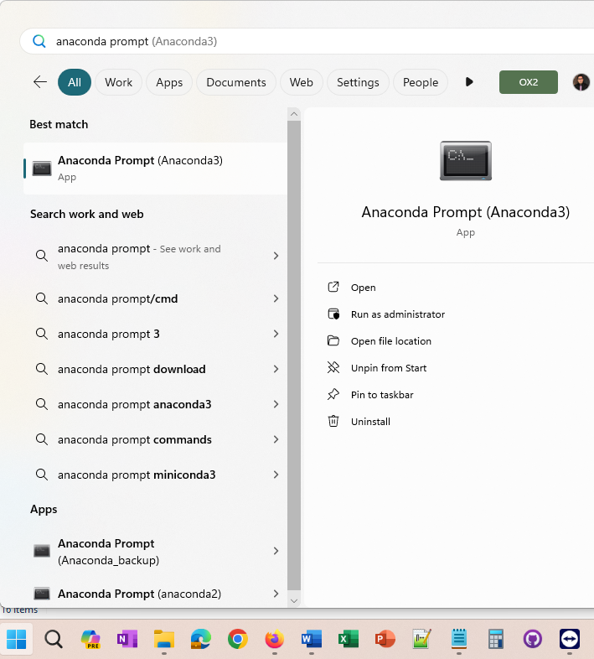

1. List all environments you need to back up! You need to write:

**Conda env list**

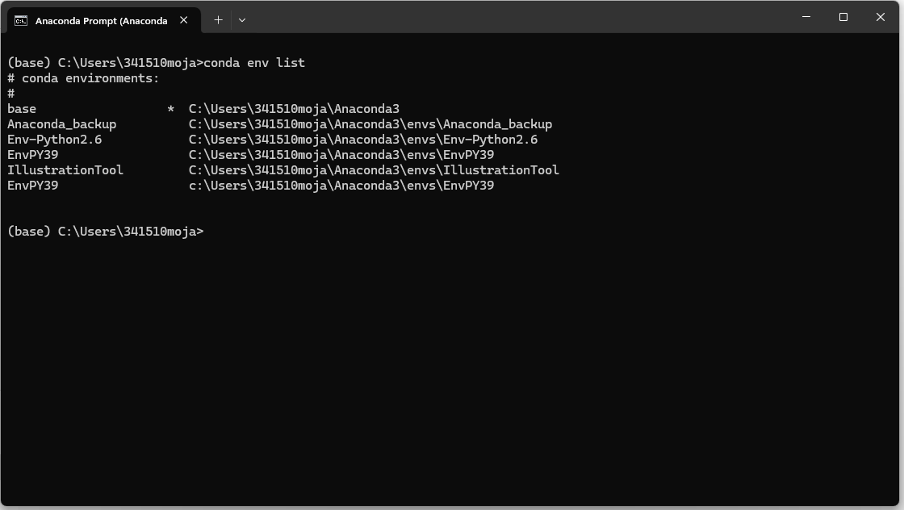



1. As you can see, the ‘base’ environment is active now as has * sign in front of it. You need to activate the environment that should backed up. For example, EnvPY39. You need to write:

**Conda activate EnvPY39**

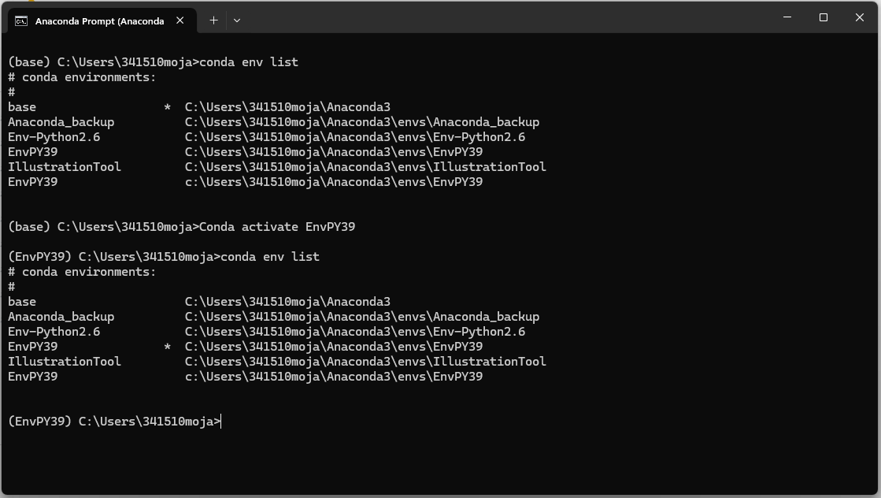



If you write **coda env list** again You can see the * sign is now in front of **EnvPY39,** which means it is the active environment now. This confirms that the environment is useable and is not a dummy name/already removed.

**NOTE**: If you do not know which one you are using now, please stay on the safe side and back up all of them. We will figure out which one is being used!

1. It is time to back up the targeted environment and save it on drive c. In the case of naming, my preference is to start it with my initials, like **MJG_ EnvPY39.** Then, IT team will know which python environment should be installed on which virtual machine (VE), if they provide us with more than one VE (fingers crossed). To back up, please write:

**conda env export --name EnvPY39> C:\Users\341510moja\Documents\MJG_EnvPY39.yaml**

**NOTE:** The preference is to save the yaml file in the Documents folder because you will get the limited admin access error when saving in some other folders, for example, c root (i.e., C:\).

1. You can see the saved file in this figure, which can be imported onto any computer. IMPORTANT: The last stage is to check if the exported file can be opened in Notepad++, which shows exact package version.

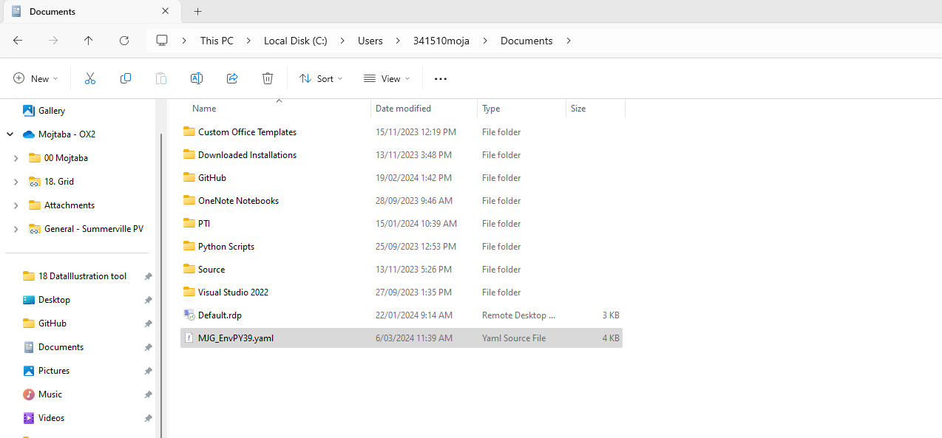

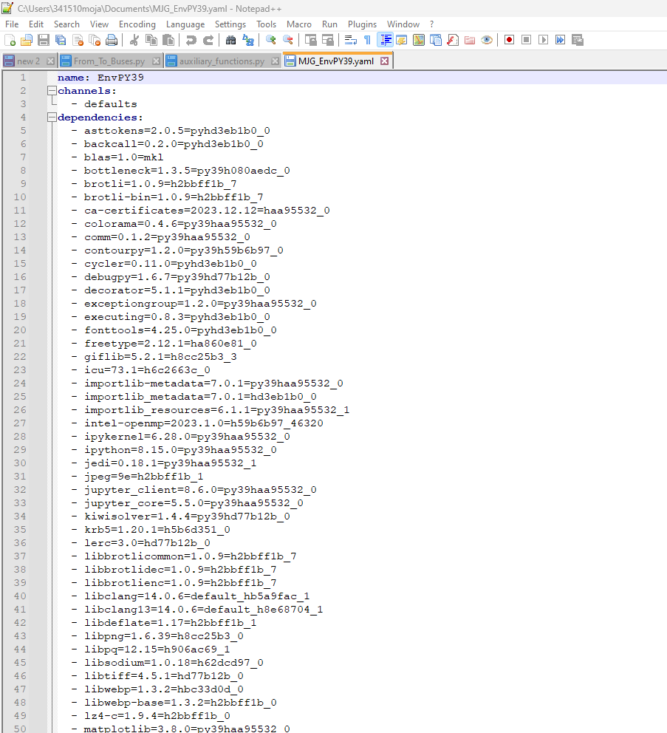

**NOTE:** Please try to back up the environment with a new shorter name if the backup file does not show the package list for any reason.